Course Code & Name: CSA12 & Computer Architecture
Assignment Title | Design and Performance Evaluation of an Intelligent Traffic Management System
Course Outcomes (COs) Covered | CO1: Analyze the functional units of a computer system including CPU, memory, bus structures, and I/O components by examining instruction execution cycles, addressing modes, and performance metrics such as CPI, clock cycles, and benchmarking  CO4: Implement hierarchical memory systems by differentiating cache levels (L1, L2, L3), virtual memory with paging, and advanced memory technologies (DRAM, SRAM, NAND Flash, MRAM, RRAM) based on latency, bandwidth, and throughput characteristics.  CO5: Construct I/O communication mechanisms by comparing memory-mapped and I/O-mapped techniques, interrupt handling (vectored, hardware, software), DMA controllers, and advanced bus interfaces including PCIe, USB, NVMe, and Thunderbolt.
SDG Mapping | SDG 9 – Industry, Innovation and Infrastructure, SDG 11 – Sustainable Cities and Communities, SDG 13 – Climate Action
BTL | L3 – Apply; L4 – Analyse; L5 – Evaluate
Problem Statement
Design, implement, and evaluate an Intelligent Traffic Management System (ITMS) for a smart, sustainable, and resilient city by integrating real-time data from traffic cameras, vehicle sensors, and road-monitoring devices. The system shall enable inclusive, safe, resilient, and sustainable urban infrastructure by efficiently processing traffic information, optimizing traffic signals, reducing congestion, and supporting priority movement of emergency vehicles.
The proposed system shall analyze suitable processor architecture, instruction sets, instruction formats, and addressing modes for efficient real-time processing of traffic and image-related data. Processor performance shall be evaluated using instruction count, CPI, clock cycles, execution time, and processor utilization, thereby supporting reliable and sustainable infrastructure, technological innovation, and resilient infrastructure development.
The system shall employ an efficient memory organization and cache configuration for high-speed processing of frequently accessed traffic data. Different cache organizations shall be compared using cache hit/miss rate, average memory access time, latency, bandwidth, and throughput to improve energy efficiency and resource utilization. The architecture shall be evaluated under normal traffic, peak-hour congestion, and emergency-vehicle scenarios, considering performance, energy consumption, cost, reliability, scalability, and resilience.
The proposed solution shall be implemented or simulated using suitable tools, with results presented through calculations, tables, graphs, and simulation outputs. The final analysis shall recommend an optimized computer architecture that promotes technological innovation, sustainable and resilient cities, and climate-conscious, energy-efficient infrastructure by reducing traffic congestion, unnecessary energy consumption, and associated environmental impact.

Deliverables To receive full credit, each submission must include the following deliverables:
1. System Architecture / Design
2. Analysis, Calculations & Results
3. Performance Comparison & Engineering Recommendation
4. Supporting Tool / Simulation Evidence, if applicable
5. Results stored in Git-Hub

Name : Jasim Asmaan A
Register Number: 192421060

Design and Performance Evaluation of an Intelligent Traffic Management System

1. System Architecture / Design
1.1 Introduction
Rapid urbanization and the growing number of vehicles have made traffic management increasingly difficult in modern cities. Conventional traffic signal systems often operate using fixed schedules, which may not respond efficiently when traffic density suddenly changes. Such systems can lead to unnecessary waiting times, increased fuel consumption, congestion, and delays for emergency vehicles.
The proposed Intelligent Traffic Management System (ITMS) applies Computer Architecture concepts to develop a more responsive traffic-control model. Information collected from traffic cameras, vehicle detectors, and road sensors is processed to determine the current condition of an intersection. The system then selects an appropriate traffic signal strategy based on the available data.
The architecture incorporates processor performance analysis, hierarchical cache memory, efficient I/O communication, and Direct Memory Access (DMA). These components are studied together to determine how an optimized computer system can support real-time traffic processing. The proposed design is tested under normal traffic, heavy congestion, and emergency situations.

1.2 Overall Architecture
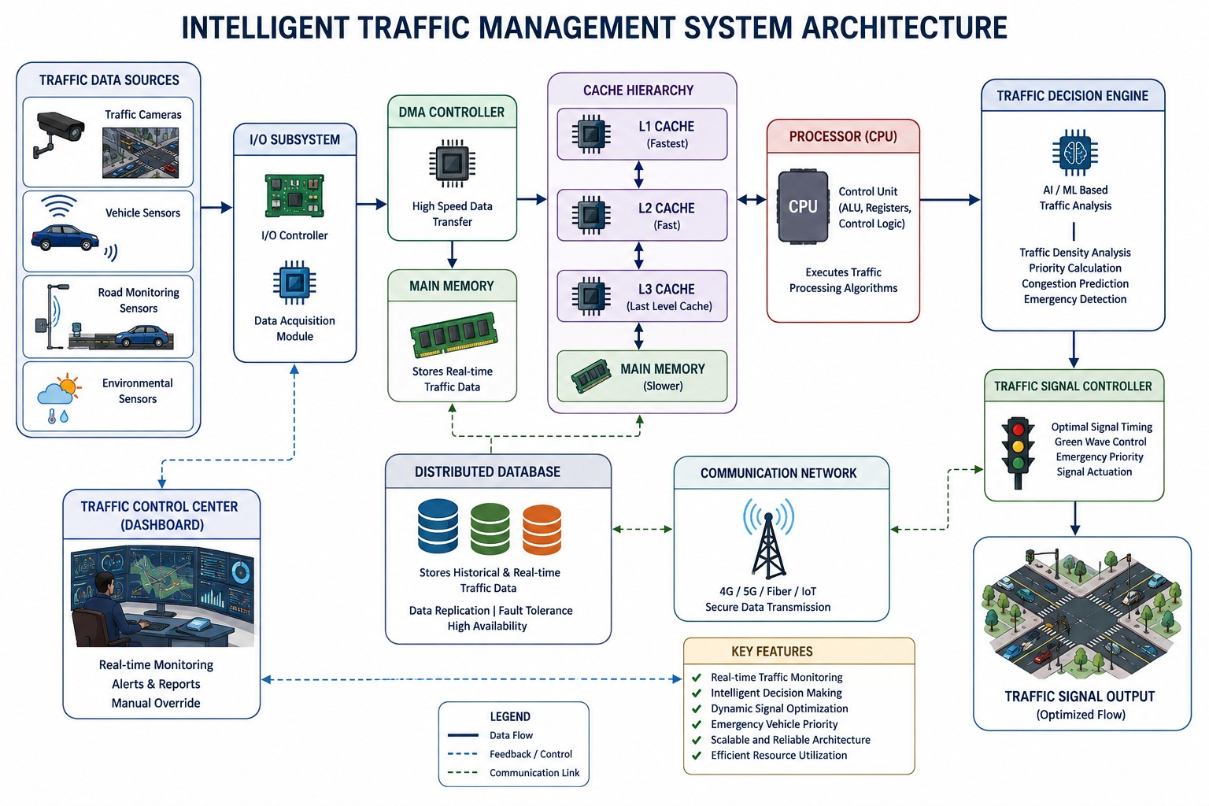
Figure 1.1 - System Architecture of the Intelligent Traffic Management System

The Intelligent Traffic Management System is designed as a sequence of connected hardware and processing components.
Traffic Cameras and Sensors → I/O Controller → DMA Controller → Main Memory → Cache Hierarchy → Processor → Traffic Analysis Unit → Signal Controller
Traffic cameras and sensors collect information from different directions of an intersection. This information may include vehicle count, traffic density, waiting duration, movement patterns, and the presence of emergency vehicles.
The collected data enters the system through the I/O subsystem. Instead of requiring the processor to manage every data transfer, the DMA controller can move large amounts of sensor data directly to main memory. This reduces processor overhead and allows the CPU to concentrate on traffic analysis.
Frequently required information is accessed through the cache hierarchy before reaching slower main memory. After processing the available traffic information, the traffic decision unit identifies the direction requiring priority and sends the appropriate command to the traffic signal controller.

1.3 Processor Architecture
A RISC-based processor model is considered suitable for the proposed system because traffic management involves a large number of simple and repetitive operations. Examples include loading sensor values, comparing traffic counts, performing arithmetic calculations, and making conditional decisions.
The processor architecture contains the following major components:
- Arithmetic Logic Unit (ALU)
- Control Unit
- Register File
- Program Counter
- Instruction Register
- Cache Interface
- Main Memory Interface
The execution of each instruction generally follows the following stages:
Instruction Fetch → Instruction Decode → Execute → Memory Access → Write Back
This processing model allows the system to evaluate how traffic-related workloads affect processor performance. Metrics such as instruction count, CPI, clock cycles, and execution time can be calculated for different traffic conditions.
1.4 Instruction Set and Addressing Modes
The proposed traffic-processing application requires instructions for data transfer, arithmetic processing, comparison, and conditional control.
The important instruction categories include:
- LOAD – Retrieves sensor or traffic information from memory.
- STORE – Saves processed traffic data.
- ADD – Performs vehicle-count and priority calculations.
- SUB – Determines differences between traffic values.
- COMPARE – Compares traffic conditions between different directions.
- BRANCH – Transfers program control based on congestion or emergency conditions.
Different addressing modes can also be used depending on the operation. Register addressing is useful for values that are accessed repeatedly during traffic calculations. Immediate addressing can be used for fixed threshold values, such as congestion limits. Memory addressing is required when retrieving sensor information stored in the memory system, while branch addressing supports conditional traffic-control decisions.

1.5 Traffic Data Processing
The proposed simulation considers a four-way road intersection consisting of the following directions:
- North
- South
- East
- West
For every direction, the system maintains important traffic-related information, including:
- Vehicle count
- Traffic density
- Waiting duration
- Road movement condition
- Emergency vehicle status
The traffic information is analyzed to determine which direction requires the next green signal. A priority value can be assigned based mainly on the number of vehicles and the current traffic condition.
Under ordinary circumstances, the direction with greater traffic demand receives higher priority. However, if an emergency vehicle is detected, the normal priority calculation is overridden to provide immediate assistance to the emergency route.

1.6 Intelligent Signal Control
The traffic signal controller operates dynamically instead of relying completely on fixed signal durations.
During normal traffic conditions, the system compares the traffic levels of all directions and selects the route with the highest demand. The green-signal duration can also be adjusted according to the number of vehicles.
During peak hours, the system experiences a greater processing load because of the increased amount of sensor and camera information. The controller gives additional importance to heavily congested directions in order to reduce excessive traffic accumulation.
When an ambulance, fire service vehicle, or another emergency vehicle is detected, the system immediately assigns priority to the corresponding route. After the emergency vehicle passes through the intersection, the controller returns to its normal adaptive operation.

2. Analysis, Calculations & Results
2.1 CPU Performance Analysis
The processor is evaluated using several important Computer Architecture performance parameters.
Instruction Count
Instruction count represents the total number of instructions executed while processing a particular traffic workload. A larger number of vehicles generally results in more instructions because additional sensor data must be processed.
Clock Cycles
The total clock cycles required by the processor are calculated as:
Clock Cycles = Instruction Count × CPI
The number of clock cycles depends on both the number of executed instructions and the average number of cycles required for each instruction.
Execution Time
Processor execution time is calculated using:
Execution Time = Clock Cycles / Clock Frequency
A lower execution time indicates faster processing of traffic information and quicker signal decisions.
CPU Utilization
CPU utilization indicates how much of the processor's available processing capacity is being used.
CPU Utilization = (Processor Busy Time / Total Available Time) × 100
The CPU workload is expected to be relatively low during normal traffic and considerably higher during peak-hour conditions.

2.2 Memory Hierarchy Analysis
traffic management system repeatedly accesses current vehicle information, traffic signal states, emergency status, and sensor readings. Accessing all this information directly from main memory would increase latency. Therefore, a hierarchical memory organization is used.
The proposed memory structure is:
L1 Cache → L2 Cache → L3 Cache → Main Memory
A sample latency configuration is shown below.
Memory Component | Approximate Access Latency
L1 Cache | 1 ns
L2 Cache | 4 ns
L3 Cache | 12 ns
Main Memory | 80 ns
The faster cache levels store frequently accessed information, while main memory contains larger datasets that are accessed less frequently.
Cache Hit Rate
Cache hit rate is calculated using:
Cache Hit Rate = (Number of Cache Hits / Total Memory Accesses) × 100
A higher hit rate generally improves overall system performance because the processor can obtain data from faster memory locations.
Cache Miss Rate
The cache miss rate can be determined as:
Cache Miss Rate = 100 − Cache Hit Rate
Average Memory Access Time
A weighted average approach is used to estimate memory access performance:
AMAT = Total Weighted Memory Access Latency / Total Number of Accesses
The multilevel cache hierarchy reduces average access time by ensuring that a large portion of frequently used traffic data is served from faster cache levels.

2.3 I/O and DMA Analysis
The traffic sensors and cameras continuously produce information that must be transferred into the computer system. Efficient data transfer is therefore essential for maintaining real-time performance.
CPU-Controlled Data Transfer
In a conventional approach, the processor may be directly involved in transferring information:
Sensor → CPU → Main Memory
This method increases the processor's workload, particularly when the system receives continuous streams of traffic data.
DMA-Based Data Transfer
Using Direct Memory Access, the transfer process becomes:
Sensor → DMA Controller → Main Memory
The DMA controller transfers data directly to memory without requiring continuous CPU involvement. Once the operation is completed, the processor can be informed through an interrupt.
The following parameters can be used to evaluate DMA performance:
- Data transfer time
- CPU involvement
- Processor time saved
- Transfer throughput
DMA becomes particularly useful during peak traffic because a greater volume of sensor information must be transferred and processed.
2.4 Traffic Scenario Analysis
Scenario 1: Normal Traffic
Normal traffic represents a relatively balanced road condition with a moderate number of vehicles.
Direction | Vehicle Count
North | 25
South | 20
East | 30
West | 22
In this situation, East has the largest number of vehicles. Therefore, the traffic controller can assign priority to the East direction.
The processor and memory systems experience a moderate workload because the quantity of incoming traffic data is comparatively limited.

Scenario 2: Peak-Hour Traffic
Peak-hour traffic represents a heavily congested situation in which significantly more information must be processed.
Direction | Vehicle Count
North | 75
South | 60
East | 95
West | 70
East again contains the largest number of vehicles and receives a higher traffic priority.
Peak-hour operation creates additional demands on the computer architecture, including:
- Increased instruction execution
- Greater processor utilization
- More frequent memory access
- Higher cache activity
- Increased I/O traffic
- Greater energy consumption
The cache hierarchy and DMA controller play an important role in maintaining efficient performance during this condition.

Scenario 3: Emergency Vehicle Condition
The emergency scenario represents a situation in which a priority vehicle approaches the intersection.
Direction | Vehicle Count
North | 45
South | 35
East | 55
West | 40
Assume that an emergency vehicle is detected on the East route. In this case, the system does not depend only on the normal traffic ranking. Instead, it immediately gives priority to East.
The control process can be represented as:
Emergency Detection → Priority Override → Green Signal Activation → Emergency Vehicle Passage → Normal Traffic Control
This mechanism helps improve response time for emergency services while allowing the system to return to normal traffic optimization afterward.

2.5 Energy Evaluation
Energy efficiency is an important factor when designing a large-scale intelligent infrastructure system.
Processor activity and memory access both contribute to overall energy consumption. A system that performs unnecessary computations or frequently accesses slow main memory may consume additional energy.
The proposed architecture improves efficiency by:
- Reducing unnecessary processor involvement during data transfer
- Using DMA for continuous sensor communication
- Storing frequently accessed information in cache memory
- Reducing average memory access latency
- Processing traffic data more efficiently
The estimated energy consumption can be related to processor activity and execution time. Faster completion of useful tasks can help reduce unnecessary resource usage.

2.6 Throughput
Throughput represents the amount of traffic information processed within a specific period.
It can be calculated as:
Throughput = Number of Processed Vehicle Records / Processing Time
A higher throughput indicates that the system can process a larger quantity of traffic information in less time.
Throughput becomes especially important during peak hours because the system must continue making timely traffic-control decisions even when the incoming data volume increases.

3. Performance Comparison & Engineering Recommendation
3.1 Comparison of Traffic Scenarios
Parameter | Normal Traffic | Peak-Hour Traffic | Emergency Scenario
Traffic Load | Moderate | Very High | Moderate to High
CPU Demand | Low to Moderate | High | High
Memory Activity | Moderate | High | High
I/O Activity | Moderate | Very High | High
Signal Control | Adaptive | Congestion Priority | Emergency Override
Response Requirement | Standard | Fast | Immediate
DMA Requirement | Useful | Highly Important | Highly Important
Reliability Requirement | Moderate | High | Very High
The Python-based simulation can generate numerical values for CPU performance, memory access behavior, DMA transfer efficiency, energy consumption, and processing throughput.

3.2 Performance Comparison
Processor Performance
The processor must execute traffic-analysis instructions within a short period to support real-time decision-making. Performance can be improved by maintaining a reasonable instruction count and reducing the average CPI.
Memory Performance
The L1, L2, and L3 cache levels reduce dependence on slower main memory. Frequently accessed traffic information can therefore be retrieved with lower latency.
I/O Performance
DMA improves I/O efficiency by reducing direct CPU participation in continuous sensor-data transfers. This becomes increasingly valuable when the traffic workload becomes large.
Traffic-Control Performance
The adaptive traffic controller responds to actual road conditions instead of following only a predefined signal schedule. This allows the system to provide different levels of priority based on congestion and emergency conditions.

3.3 Engineering Recommendation
Based on the analysis, the most suitable configuration for the proposed Intelligent Traffic Management System is a processor architecture supported by a multilevel cache hierarchy and DMA-enabled I/O communication.
A RISC-oriented processor is suitable because the application mainly performs repetitive arithmetic, comparison, loading, storing, and branching operations. A multilevel cache system can improve data-access performance by keeping frequently used traffic information close to the processor.
The recommended configuration includes:
- RISC-oriented processor architecture
- L1, L2, and L3 cache hierarchy
- Main memory for large traffic datasets
- DMA controller for sensor-data transfer
- Interrupt-based notification after major I/O operations
- Adaptive traffic signal algorithm
- Emergency priority mechanism
This architecture provides a reasonable balance between processing speed, energy efficiency, cost, reliability, scalability, and resilience.
4. Supporting Tool / Simulation Evidence
The proposed Intelligent Traffic Management System is simulated using Python.
The simulation represents the following operations:
- Collection of traffic sensor information
- Vehicle-count processing
- Traffic-priority determination
- Processor instruction execution
- CPU performance calculation
- Cache and memory hierarchy analysis
- DMA-based data transfer
- Emergency vehicle detection
- Adaptive signal control
- Throughput estimation
- Energy estimation
The system is tested using three different conditions:
Normal Traffic → Peak-Hour Traffic → Emergency Vehicle
The simulation generates values related to:
- Instruction count
- CPI
- Clock cycles
- Execution time
- CPU utilization
- Cache access behavior
- Average memory access time
- DMA transfer performance
- CPU time saved
- Estimated energy consumption
- Processing throughput
The generated outputs and screenshots can be included as evidence of the implementation and performance evaluation.

Code:
def run_system(scenario):

if scenario == "Normal":
traffic = {"North": 25, "South": 20,
"East": 30, "West": 22}
emergency = None

elif scenario == "Peak Hour":
traffic = {"North": 75, "South": 60,
"East": 95, "West": 70}
emergency = None

else:
traffic = {"North": 45, "South": 35,
"East": 55, "West": 40}
emergency = "East"

print("\n======================================")
print("SCENARIO :", scenario)
print("======================================")

print("\nTRAFFIC SENSOR DATA")

for direction, vehicles in traffic.items():
print(direction, ":", vehicles, "vehicles")

if emergency:
print("\nEMERGENCY VEHICLE DETECTED :", emergency)

if emergency:
priority = emergency
green_time = 60
else:
priority = max(traffic, key=traffic.get)
green_time = 30 + traffic[priority] // 5

print("\nTRAFFIC SIGNAL DECISION")
print("Priority Direction :", priority)
print("Green Time :", green_time, "seconds")

total_vehicles = sum(traffic.values())

instruction_count = total_vehicles * 1000

if scenario == "Normal":
cpi = 1.2
elif scenario == "Peak Hour":
cpi = 1.8
else:
cpi = 1.5

clock_cycles = instruction_count * cpi

frequency = 2.5 * 10**9

execution_time = clock_cycles / frequency

cpu_utilization = min(
100,
execution_time * 100000
)

print("\nCPU PERFORMANCE")
print("Instruction Count :", instruction_count)
print("CPI :", cpi)
print("Clock Cycles :", int(clock_cycles))
print("Execution Time :",
round(execution_time * 1000, 4), "ms")
print("CPU Utilization :",
round(cpu_utilization, 2), "%")

l1_hit = 70
l2_hit = 20
l3_hit = 7
ram_access = 3

l1_latency = 1
l2_latency = 4
l3_latency = 12
ram_latency = 80

amat = (
l1_hit * l1_latency +
l2_hit * l2_latency +
l3_hit * l3_latency +
ram_access * ram_latency
) / 100

print("\nMEMORY HIERARCHY")
print("L1 Hit Rate :", l1_hit, "%")
print("L2 Hit Rate :", l2_hit, "%")
print("L3 Hit Rate :", l3_hit, "%")
print("RAM Access :", ram_access, "%")
print("AMAT :", round(amat, 2), "ns")

cpu_transfer = total_vehicles * 0.08
dma_transfer = total_vehicles * 0.02
cpu_saved = cpu_transfer - dma_transfer

print("\nI/O AND DMA")
print("CPU Transfer Time :",
round(cpu_transfer, 2), "ms")
print("DMA Transfer Time :",
round(dma_transfer, 2), "ms")
print("CPU Time Saved :",
round(cpu_saved, 2), "ms")

energy = execution_time * 45

print("\nENERGY")
print("Estimated Energy :",
round(energy, 6), "J")

throughput = total_vehicles / execution_time

print("\nTHROUGHPUT")
print("Processing Rate :",
round(throughput, 2),
"vehicles/second")

print("\n======================================")
print("SIMULATION COMPLETED")
print("======================================")

while True:

print("\n======================================")
print(" INTELLIGENT TRAFFIC MANAGEMENT SYSTEM")
print("======================================")
print("1. Normal Traffic")
print("2. Peak Hour Traffic")
print("3. Emergency Vehicle")
print("4. Run All Scenarios")
print("5. Exit")
print("======================================")

choice = input("Enter choice: ")

if choice == "1":
run_system("Normal")

elif choice == "2":
run_system("Peak Hour")

elif choice == "3":
run_system("Emergency")

elif choice == "4":
run_system("Normal")
run_system("Peak Hour")
run_system("Emergency")

elif choice == "5":
print("System terminated.")
break

else:
print("Invalid choice.")

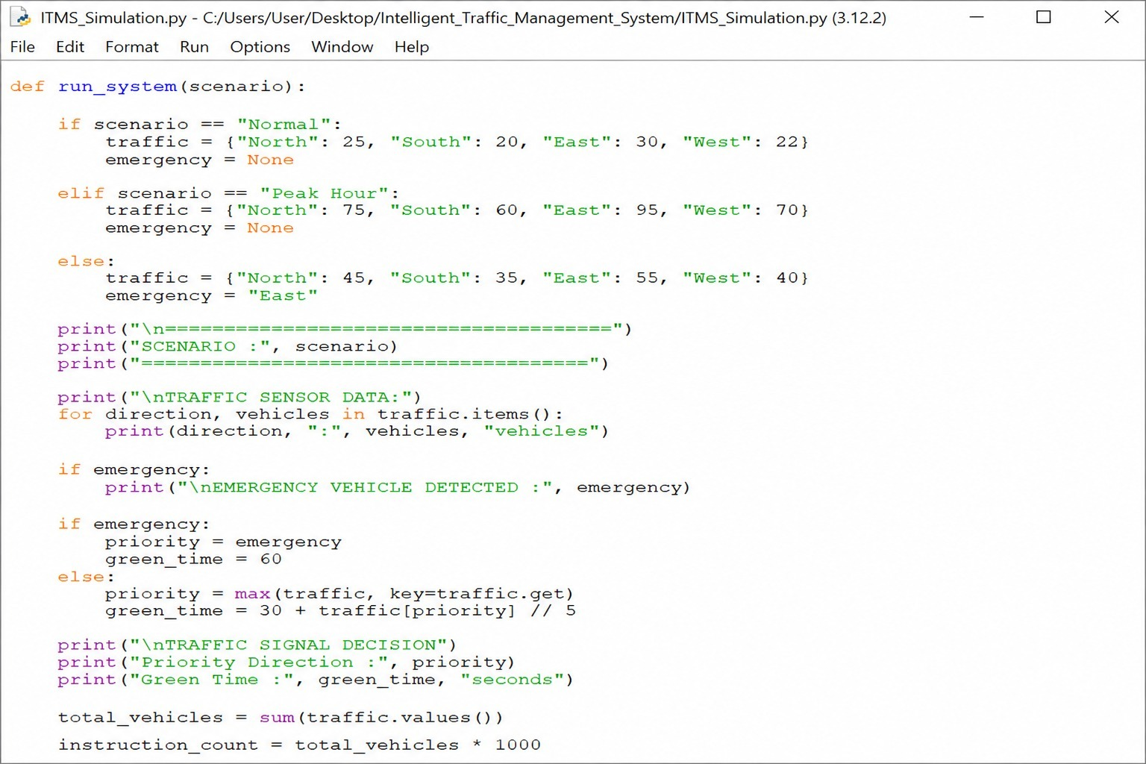
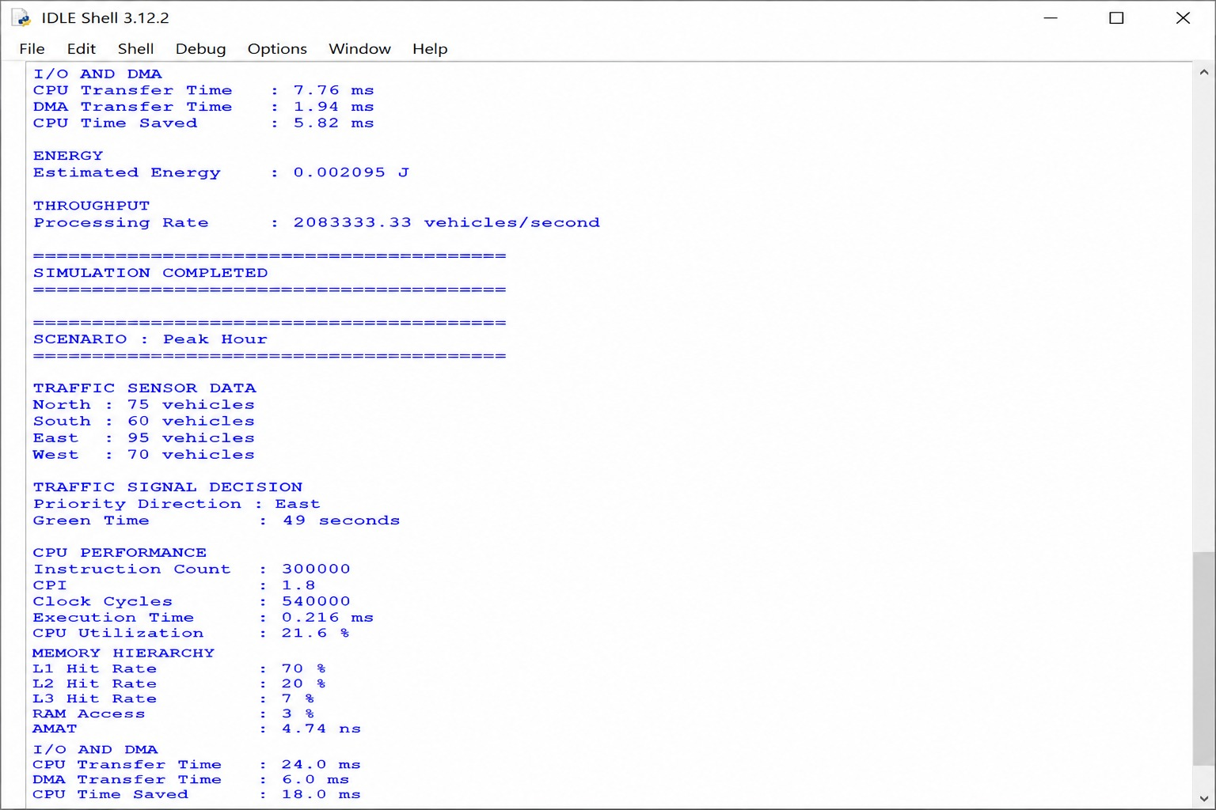

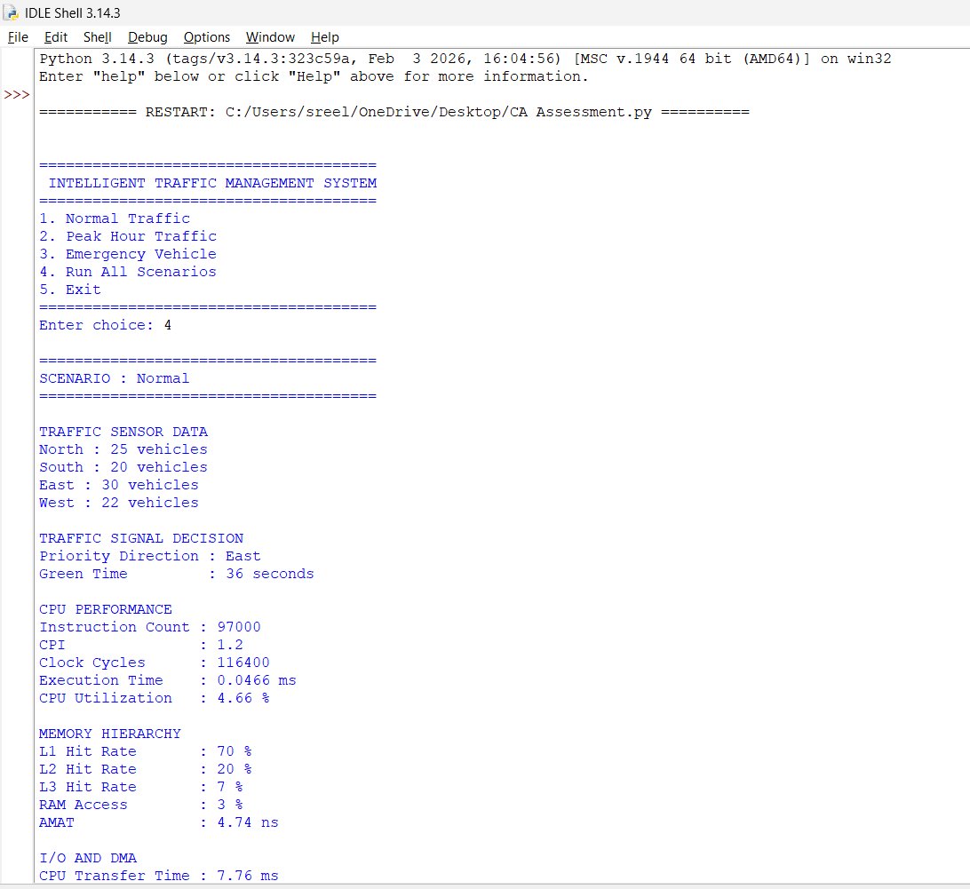

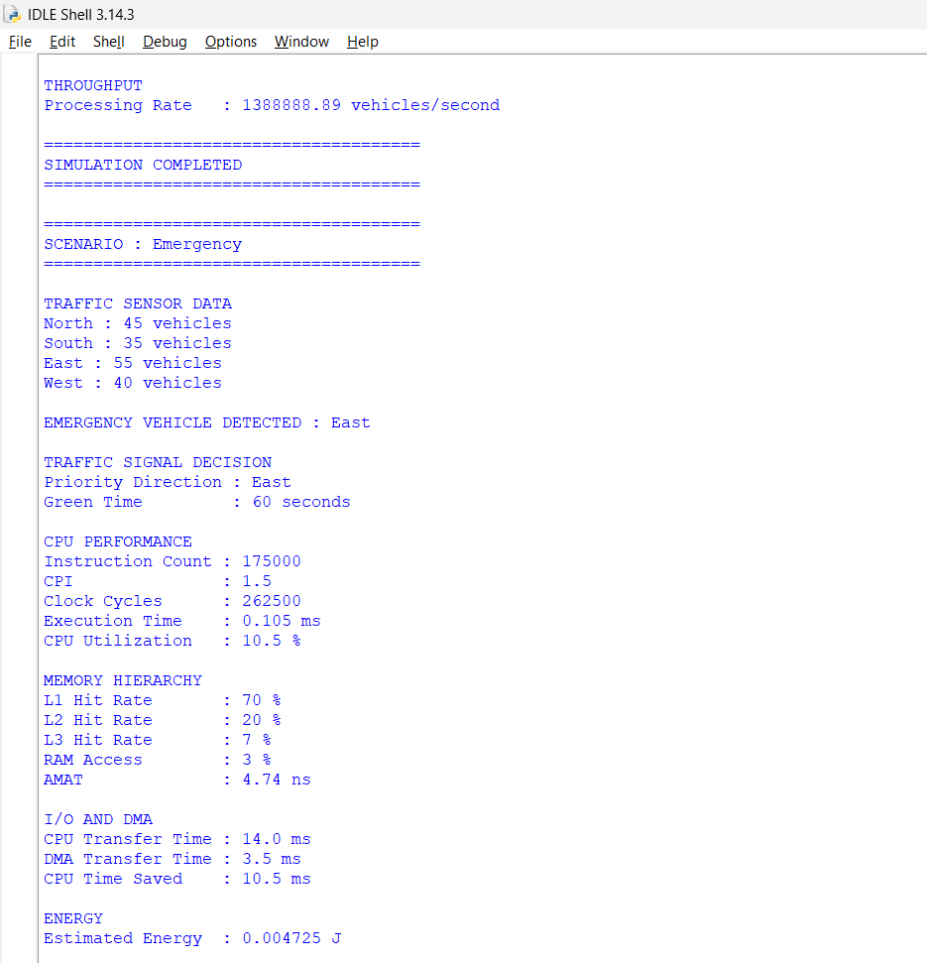

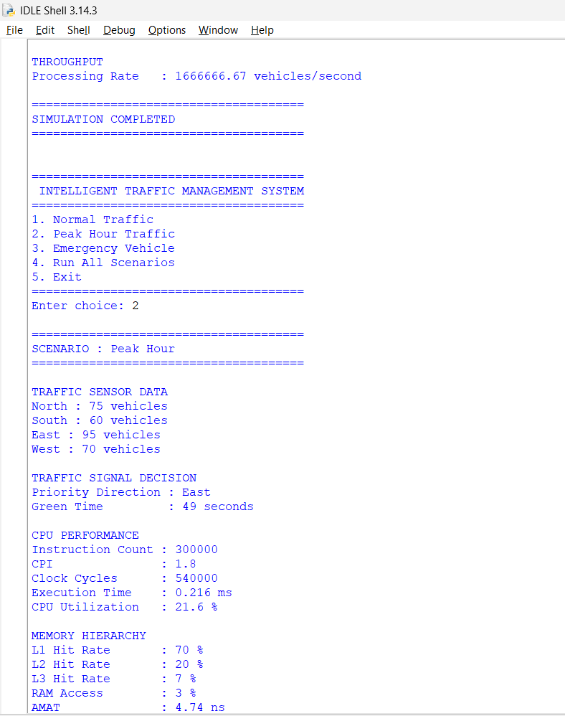
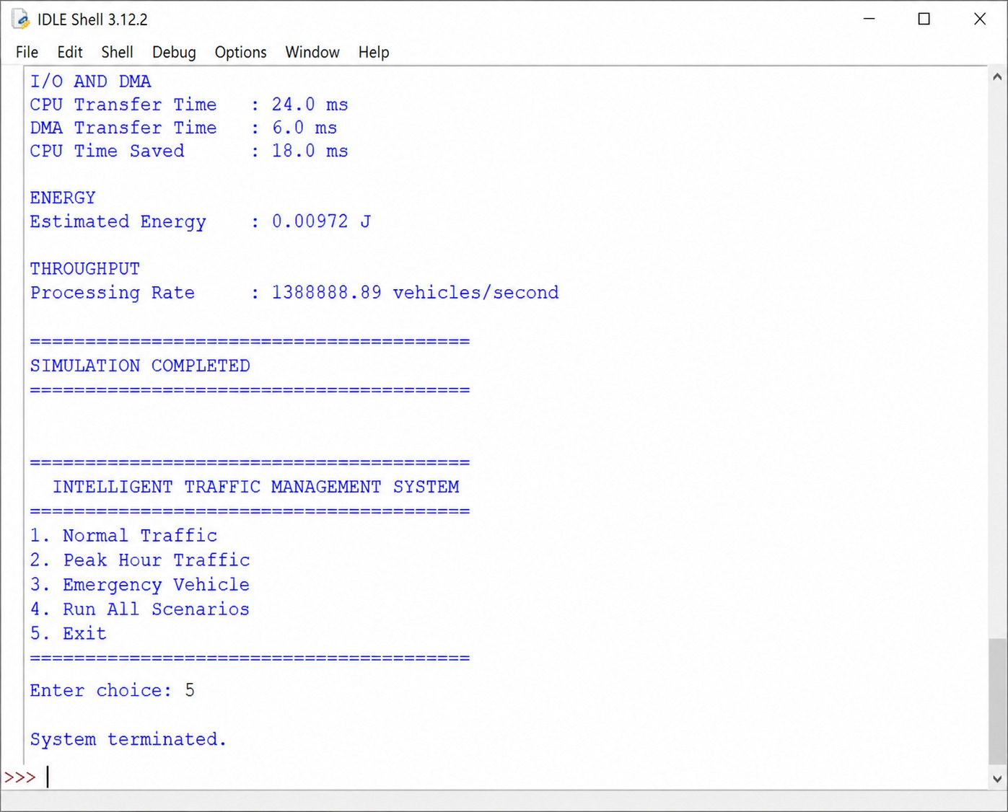

5. Results and Discussion
The simulation demonstrates that the amount of traffic directly affects the workload imposed on the processor, memory system, and I/O components.
Under normal traffic conditions, the system processes a moderate amount of information and requires fewer computational resources. During peak hours, the number of vehicles and sensor events increases, leading to a larger instruction count, higher processor activity, and greater memory and I/O requirements.
The cache hierarchy improves system performance by allowing frequently used information to be accessed from faster memory levels. This reduces the number of costly accesses to main memory and contributes to lower average memory latency.
DMA also improves the overall architecture by transferring sensor information without requiring the processor to manage every stage of the transfer. As a result, more CPU resources remain available for traffic analysis and signal-control decisions.
The emergency scenario demonstrates the importance of priority-based processing. When an emergency vehicle is detected, the system can temporarily modify its normal traffic strategy and immediately provide a suitable route. After the emergency situation has been handled, the system resumes its regular adaptive traffic operation.

6. Conclusion
The Intelligent Traffic Management System presented in this project demonstrates the practical application of Computer Architecture principles in the development of modern urban infrastructure.
The proposed system combines real-time traffic sensing, processor-based computation, multilevel cache memory, DMA-supported I/O communication, and adaptive signal control. These components work together to process traffic information and make suitable decisions under different operating conditions.
Processor performance is evaluated using instruction count, CPI, clock cycles, execution time, and CPU utilization. The memory system is examined using cache performance, latency, and average memory access time. DMA is incorporated to reduce unnecessary processor involvement when transferring continuous sensor data.
The three simulated scenarios demonstrate the ability of the architecture to handle ordinary traffic, increased peak-hour workloads, and emergency vehicle priority. The results indicate that the combination of efficient processor operation, hierarchical memory, and optimized I/O communication can provide improved responsiveness for an intelligent traffic-control environment.
The recommended architecture consists of a RISC-oriented processor, multilevel cache memory, DMA-based data transfer, and adaptive traffic-signal control. This combination offers a balanced approach to performance, energy efficiency, reliability, scalability, and system resilience.
The project also supports the objectives of SDG 9 – Industry, Innovation and Infrastructure, SDG 11 – Sustainable Cities and Communities, and SDG 13 – Climate Action. By reducing unnecessary traffic delays and improving road utilization, an intelligent traffic management system can contribute towards more efficient, sustainable, and technologically advanced urban environments.
The recommended architecture therefore combines RISC-style processing, multilevel cache memory, DMA-based I/O, and intelligent signal control to achieve a balance between responsiveness, efficiency, scalability, resilience, and energy-conscious operation.
The proposed system contributes to the development of intelligent transportation infrastructure and supports the objectives of SDG 9, SDG 11, and SDG 13 through technological innovation, improved urban mobility, and reduced resource wastage caused by inefficient traffic operation.

